James Tilly Matthews (1770 - 1815)
The Air Loom
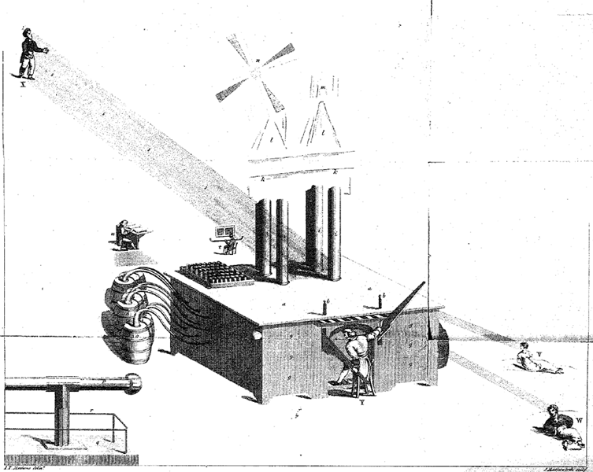

Références:
http://www.theairloom.org/text.html
John Haslam, Illustrations of Madness: Exhibiting a Singular Case of Insanity, And a No Less Remarkable Difference in Medical Opinions: Developing the Nature of An Assailment, And the Manner of Working Events; with a Description of Tortures Experienced by Bomb-Bursting, Lobster-Cracking and Lengthening the Brain. Embellished with a Curious Plate, Londres, G. Hayden for Rivingtons, 1810
John Haslam, Roy Porter, David Williams, Politiquement fou : James Tilly Matthews, trad. de l'anglais par Hélène Allouch et préfacé par Lucien Favard, Paris, École lacanienne de psychanalyse, 1996
Mike Jay, A Visionary Madness: The Case of James Tilly Matthews and the Influencing Machine, North Atlantic Book, 2014 (The Air Loom Gang, 2004)

